Click the “Download OpenVPN_Server_Anybus_Defender.zip” button
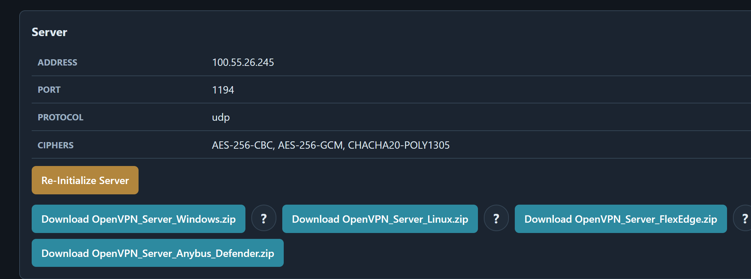
Download and Extract the OpenVPN_Server_Anybus_Defender.zip
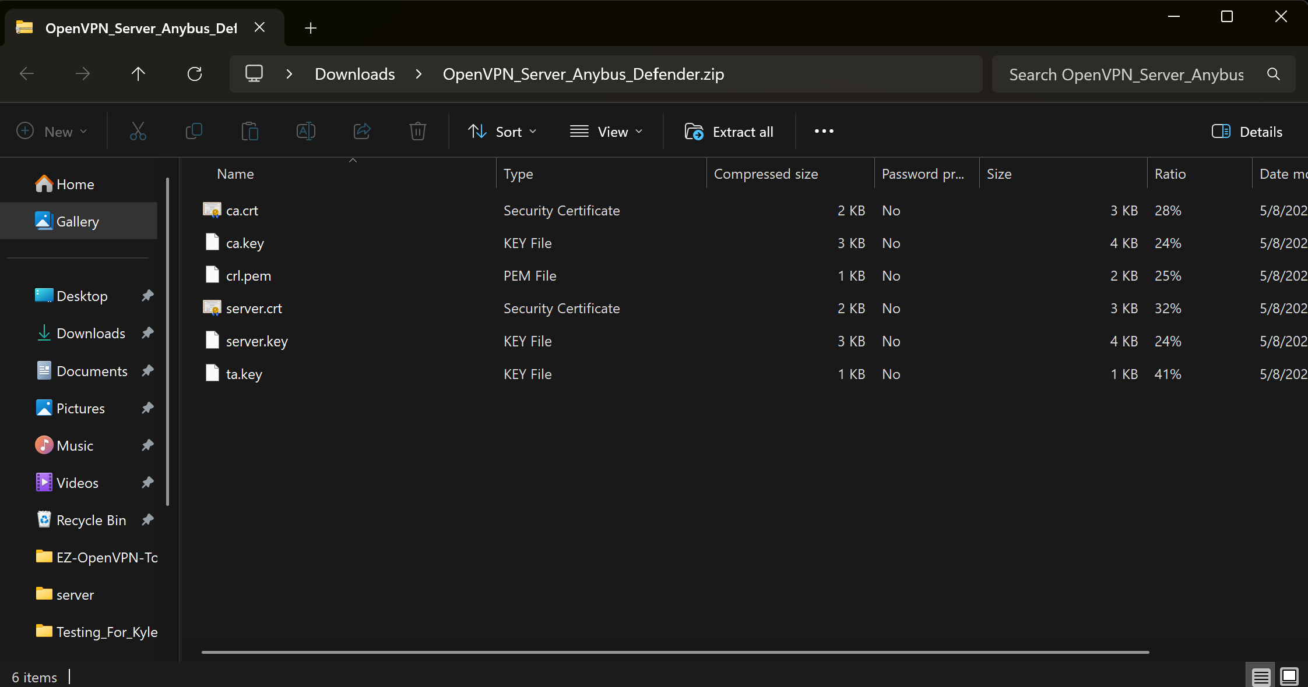

Configure the WAN Firewall Rule for OpenVPN
In the Anybus Defender Web GUI, navigate to: Firewall → Rules → WAN
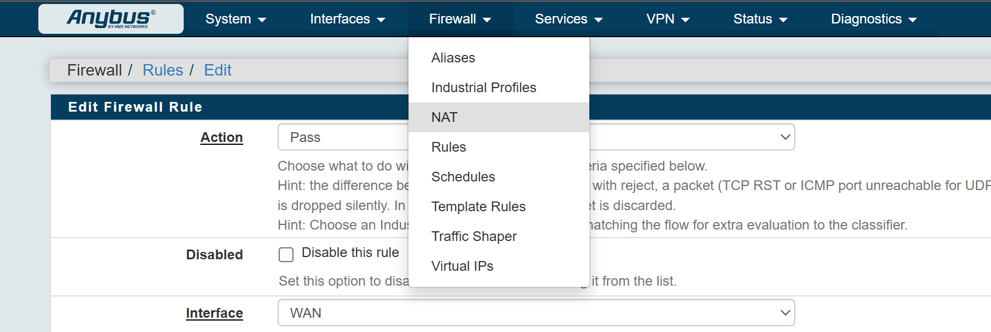
Set with these rules
- Action = Pass
- Interface = WAN
- Source = Any
- Destination> Destination Port Range = From OpenVPN (1194) From OpenVPN (1194)
- Description = Set this as you will (ex. Gregs_OVPN_Port)
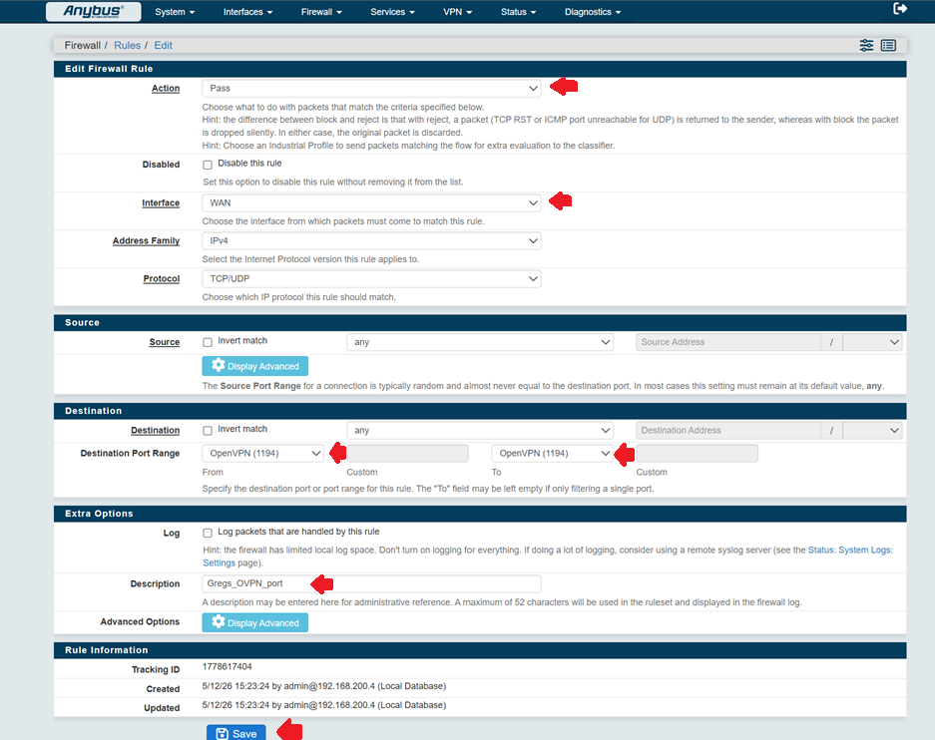
Then click Save

Import the Certificate Authority (CA)
Navigate to: System → Certificate Manager → CAs
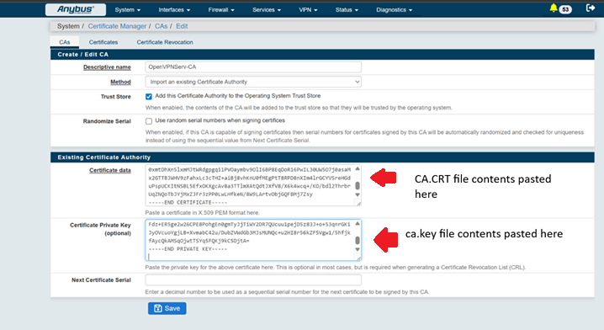
Open ca.crt in a text editor such as Notepad++.
Copy all contents from the file and paste them into the Certificate Data field.
Do the same for ca.key
Import the OpenVPN Server Certificate
Now let’s import the server.crt and server.key contents
Navigate to: System → Certificate Manager → Certificates
Then click Add.
Open server.crt in a text editor such as Notepad++.
Copy all contents from the file and paste them into the Certificate Data field.
Paste the contents and then click ‘Save’
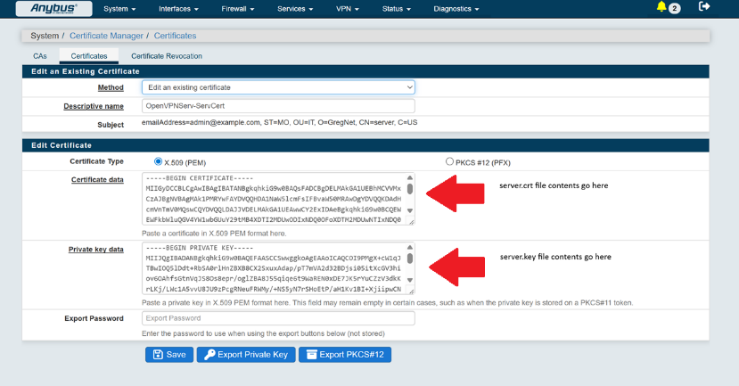
Do the same for server.key
Click Save when complete.
Navigate to: System → Certificate Manager → Certificate Revocation
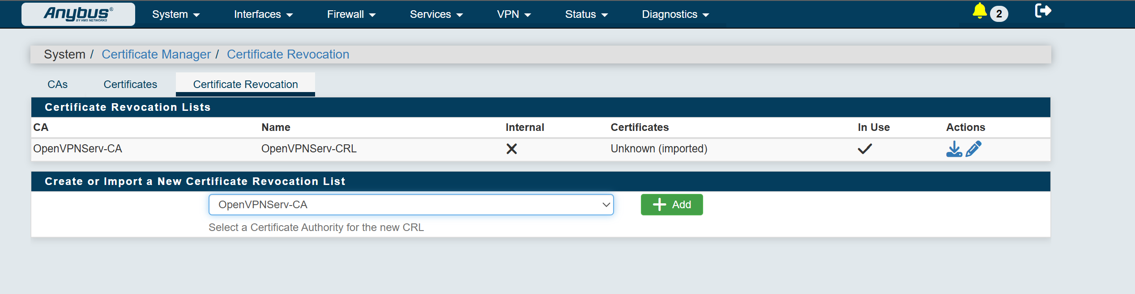
Select your imported Certificate Authority from the dropdown menu and click Add.
Open crl.pem in a text editor such as Notepad++.
Copy all contents from the file.
Paste the contents into the CRL Data field.
Click Save when complete.

Next let’s go to VPN>OpenVPN>Servers
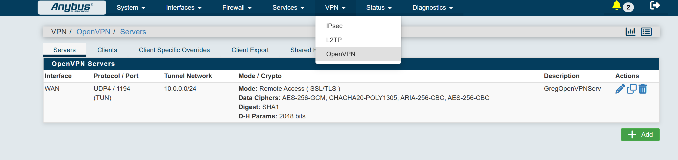
Add a new VPN Server
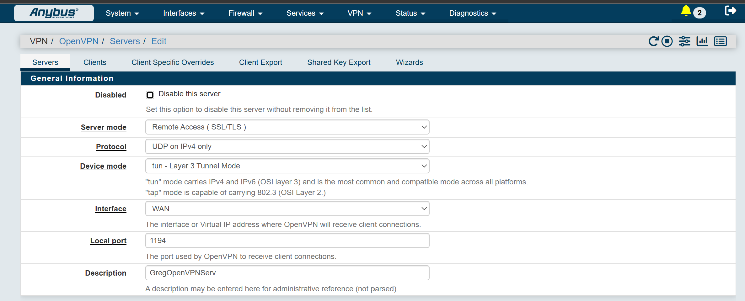
- Server Mode = Remote Access (SSL/TLS)
- Protocol = Select the Protocol you chose during initialization (UDP/TCP)
- Device Mode = tun – Layer 3 Tunnel Mode
- Interface = WAN
- Local Port = Port you specified during initialization
- Description = Can be whatever you like
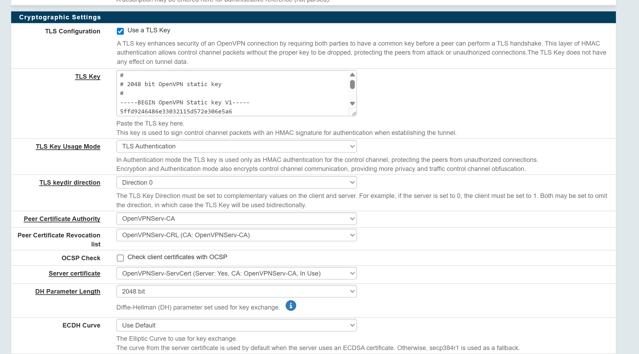
- TLS Configuration = Use a TLS Key
- TLS Key = Paste contents of ta.key
- TLS Key Usage Mode = TLS Authentication
- TLS keydir direction = Direction 0
- Peer Certificate Authority = Select your imported ca.crt and ca.key files in the dropdown
- Peer Certificate Revocation List = Select your imported crl.pem file from the dropdown
- Server Certificate = Select your imported server.crt and server.key files from the dropdown
- DH Parameter Length = 2048 bit
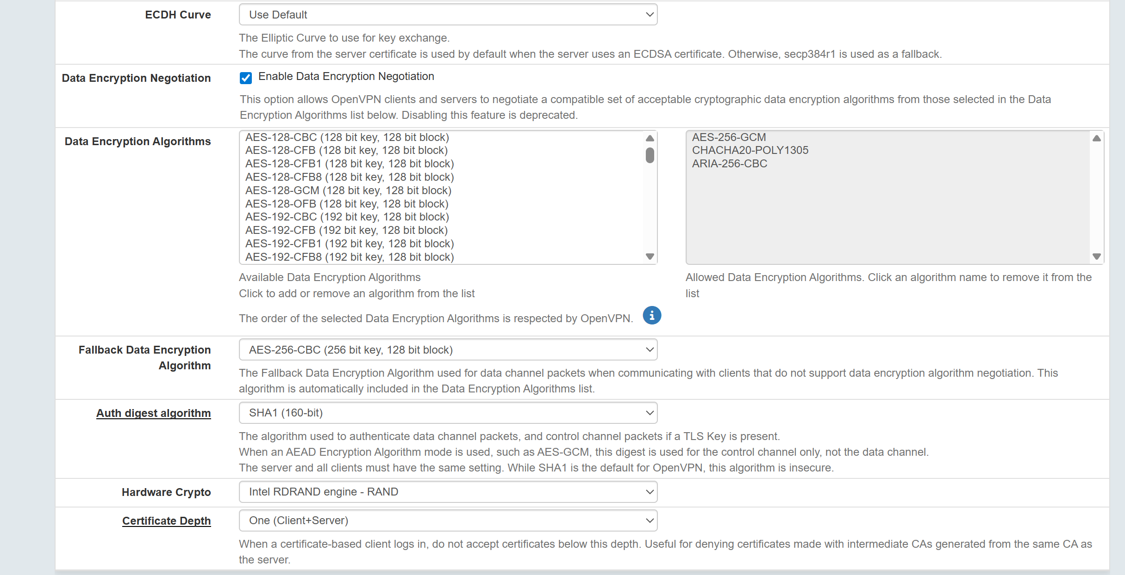
- Data Encryption Algorithms = Select the Algos that you specified during initialization
- Fallback Data Encryption Algorithm = Select the least of the algos you specified during initialization
- Auth digest algorithm = SHA1 (160-bit) is the default, should you choose anything different you will need to modify all client.(conf/ovpn) files to reflect that.
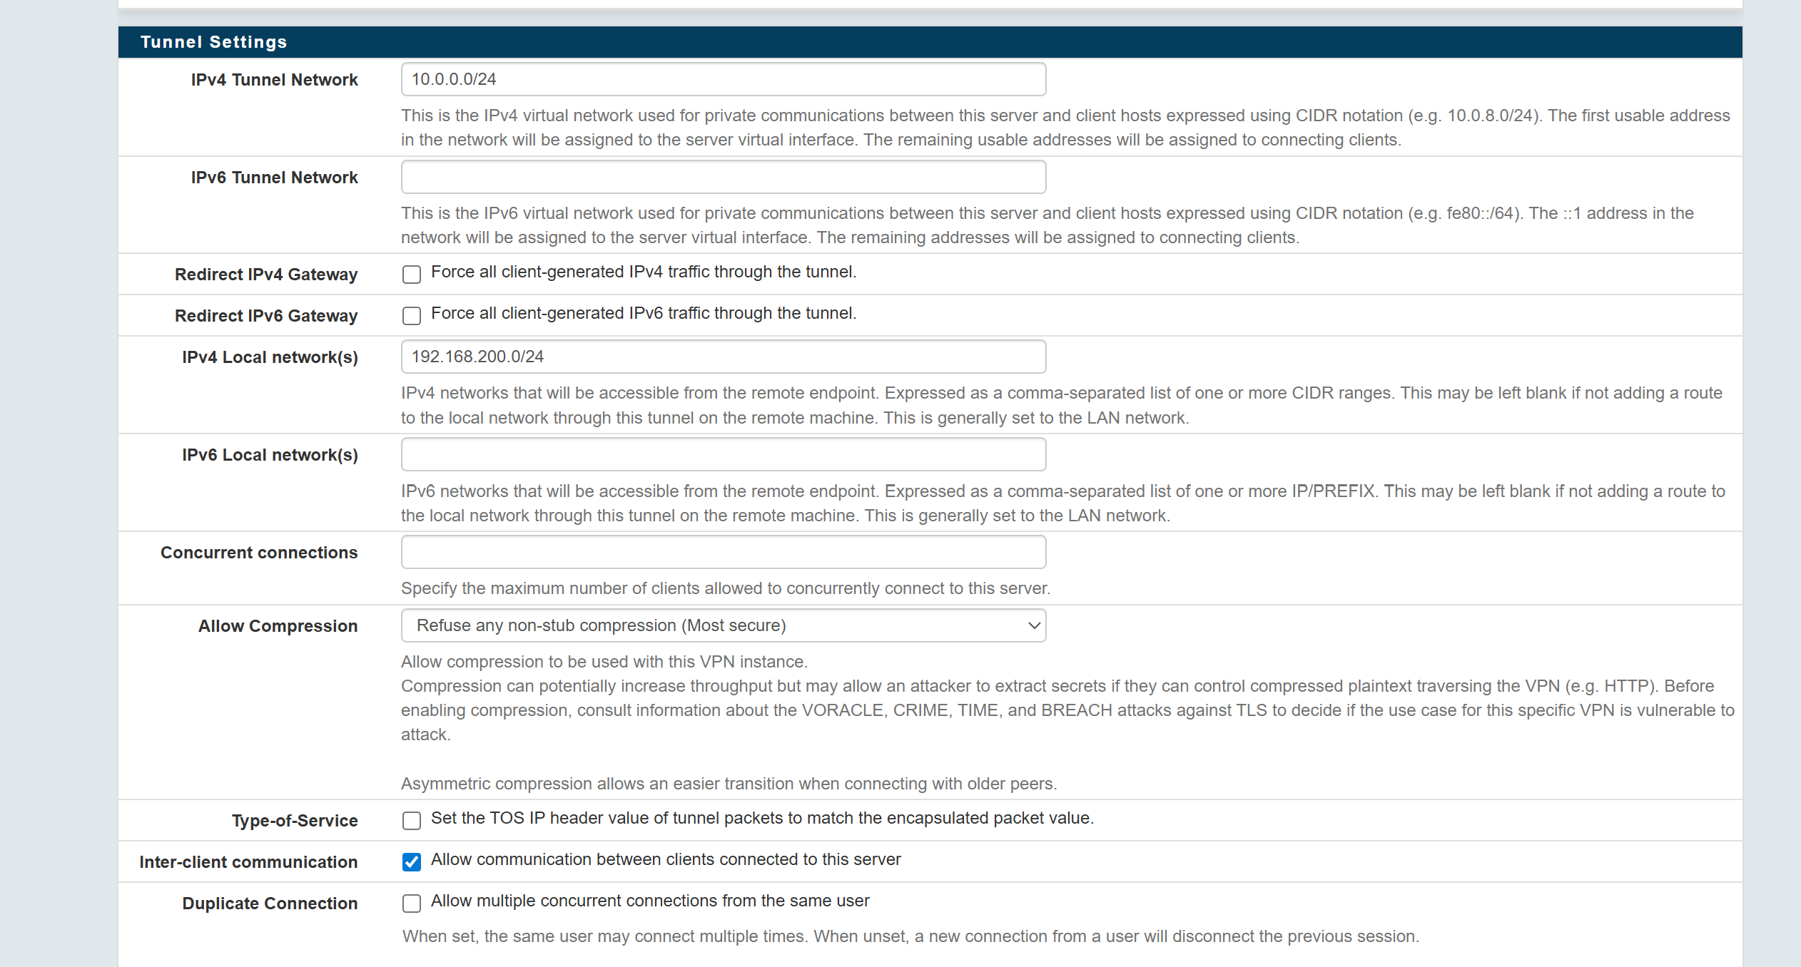
- IPv4 Tunnel Network = Subnet of OpenVPN tunnel network
- IPv4 Local Network = Subnet of LAN network on Anybus Defender
- Inter-client communication = Allow
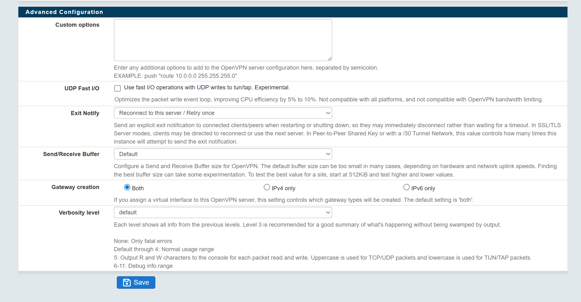
All other settings can be left as default

